Noise and texture generator.

[Company name] | [Company address]

[Document subtitle]

17BriceJ

[Year]

Contents

Analysis 2

Problem Identification 2

Computational Methods 2

Stakeholders 2

Research 2

Website 1 2

Website 2 2

Website 3 2

Essential Features 2

Limitations 2

Hardware And Software Requirements 2

Success Criteria 2

Design 2

Decomposition 2

Explanation of the process 2

Solution structure 2

Iterative development 2

Example 2

Post development testing 2

Testing 2

Usability testing 2

Evaluation 2

Success criteria 2

Unmet criteria 2

Usability features 2

Maintenance issues 3

Limitations 3

# Analysis

## Problem Identification

In 3D design and modelling, Displacement maps and normal maps are used to ‘displace’ 3 dimensional meshes. They add surface detail without requiring more vertices in the mesh. This means models require fewer vertices to get the same detail. This means models using this technique take less memory and storage space. These maps are often made with types of procedurally generated noise layered on top of each other. These are saved as bitmaps. Normal maps are superior to displacement maps, as they use the RGB colour values to displace values in XYZ. Most 3D programs support some types of noise, but these mostly run on the CPU and cannot run in real time. Noise generation is evaluated per pixel, so it is a good candidate for GPU processing, as each pixel can be evaluated on a different core.

## Computational Methods

## Stakeholders

Ben Wigley

Ben is a 3D modeller that frequently uses displacement and noise maps while modelling in his spare time. He is limited by his laptops processing power, and needs the program to run efficiently. He needs a free program with customisable noise size and detail, and needs to be able to save the bitmaps in different resolutions. He also wants comprehensive online documentation in case he forgets.

Alfie Bacon

### Takeaways from stakeholder interviews

* Must run in real time
* Must have easily configurable noise settings.
* Must be able to save bitmaps in varying sizes

## Research

### Source 1

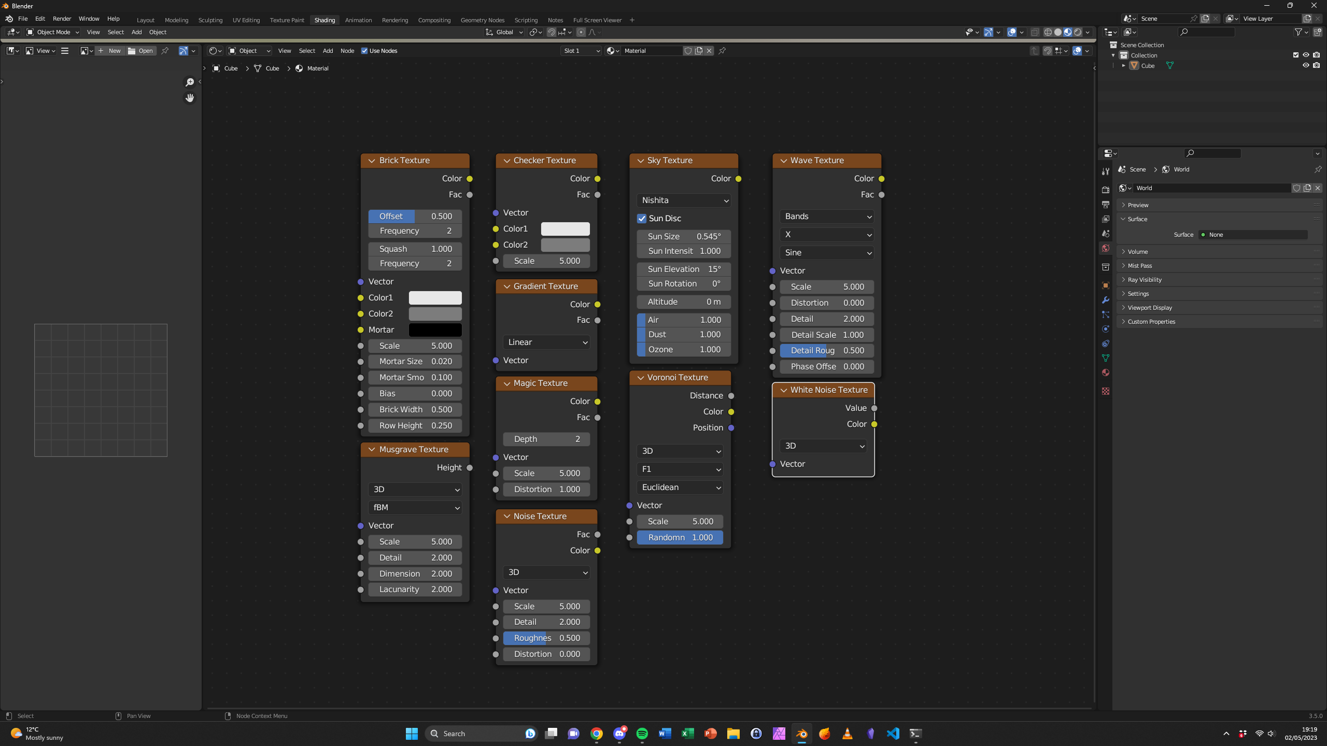

Blender is a free piece of software that has many different options for generating noise. The node-based user interface makes it very powerful but can be hard for beginners to master. Connections can be dragged between nodes, allowing quick development. The colour coded connections prevent any erroneous connections, making it quite user friendly. However, the online documentation is very scarce and non-intuitive. This is something I will strive to address with my project. The slider inputs also allow easy modification of input values. One problem with Blender is that it evaluates the nodes on the CPU, which can lead to slow response times on detailed models. I hope to address this by running my code on compatible NVIDIA graphics cards with the CUDA toolkit.

### Website 1

<https://core.ac.uk/download/pdf/250147208.pdf>

This paper talks about the methods behind generating noise, and how they can be used in video games to generate terrain. The methods explained in the paper will help when designing the back-end functionality of the program.

### Website 3

## Essential Features

## Limitations

## Hardware And Software Requirements

## Success Criteria

# Design

## Decomposition

## Explanation of the process

## Solution structure

## Iterative development

### Example

#### Introduction

#### Algorithm

#### Variables and data structures

#### Identify test data

#### Coding

#### Testing

#### Failed test fixes

#### Evaluation

## Post development testing

### Testing

### Usability testing

# Evaluation

## Success criteria

## Unmet criteria

## Usability features

## Maintenance issues

## Limitations